Acl stand for access control list its about how we control acees to the s3 and its object, before we understand about acl enable now we will understand the acl disable
In acl we can give read and write access and we can do it with tic marks but in acl disable we have to createthe policies and they are in json formate
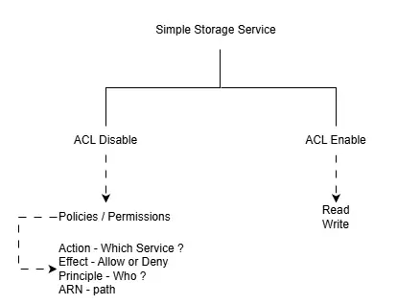

We also using ARN (Amezon Resource number) every bucket and object has a arn and using arn we have to mention action , effect , principle.
Lets suppose I have an bucket and in that bucket I created 4 foldrs named images, mydata, myfiles, videos
And I have some condition for the folder and upload 2 objects in each folder
After that I will set some condition for each folder and we will see how to apply the conditions for the the buckets
1 create a bucket select general purpose – give a name click on Acl disable – uncheck the block all access click on I acknowledge and creae the bucket
Then create 4 folders according to task
And upload 2 objects n each
The conditions are
Images – make one object in this folder private
Mydata - private
myfiles – cant be deleted
videos – no one can upload in this folder
Now our bucket is public while the folders we have to add policy that will be our 1st policy
Now after uploading 2 objects in each folder
Go to the permissions and click on edit button of bucket policy and click on policy generator you can see Ex - Bucket ARN arn:aws:s3:::bucket4501 something like this copy it and then a new tab will opened here we can create our policies in json format
1st policy will be to make all folder public
-choose s3 bucket policy in type of policy
-In effect choose allow through this we can allow or deny the permission to read(public/private)
-principle * it means all
-action search getobject
-in arn paste the amezon resource name/* and click on add

2nd policy one img private
-choose s3 bucket policy in type of policy
-In effect choose deny
-principle * it means all
-action search getobject
-in arn paste the Amazon Resource Name (ARN) of the img which you are going to make private you can find it in img above object url copy the arn and paste it nto the policy generators arn and click on add

3rd^{nd} policy mydata private
-choose s3 bucket policy in type of policy
-In effect choose deny
-principle * it means all
-action search getobject
-in arn paste the arn/mydata (file name)/* and click on add

4th policy myfile no deletion
-choose s3 bucket policy in type of policy
-In effect choose deny
-principle * it means all
-action search deleteobject
-in arn paste the amezon resource name/myfiles/* you can find it in img above object url and click on add

5th policy myfile no deletion
-choose s3 bucket policy in type of policy
-In effect choose deny
-principle * it means all
-action search putobject
-in arn paste the amezon resource name/videos/* you can find it in img above object url and click on add

Now all the 5 statement are the policies according to our arrangements so click on generate policy copy the code and go to previous tab and paste it on bucket policy and save changes and check your policies working accordingly as you instructed or not
- Try accesing the public and private img on browser
- Try any objects in my data folder in browser
- Try deleting objects from myfiles
- Try uploading objects in videos

The principles I know are using effect we can alow or deny them
Getobject – read (public) / grants permission
Putobject – write (edit) / upload files
Listobject – see the names and metadata
According to our requirement we can assign the policy to the particular object or entire bucket

